**Task Description:**

Create a windows Vm machine in AWS and connect with RDP open CMD in windows share the about system info.

**Step 1: Go to EC2 Dashboard and Launch instances**

**Step 2: Under the “Amazon Machine Images (AMI)” section, select a Windows Server version (e.g., Windows Server 2019 Base or Windows Server 2022 Base).**

**Step 3: Select Instance type**

**Step 4: In Network settings – Allow RDP traffic from**

**Step 5: Launch the instance**

**Step 6: Locate the public IP address of the Instance**

**Step 7: Download Remote Desktop File**

**Step 8: Decrypt Password**

**Step 9: Connect the download RDP file and enter the credentials**

**Step 10: Windows VM is connecting through RDP**

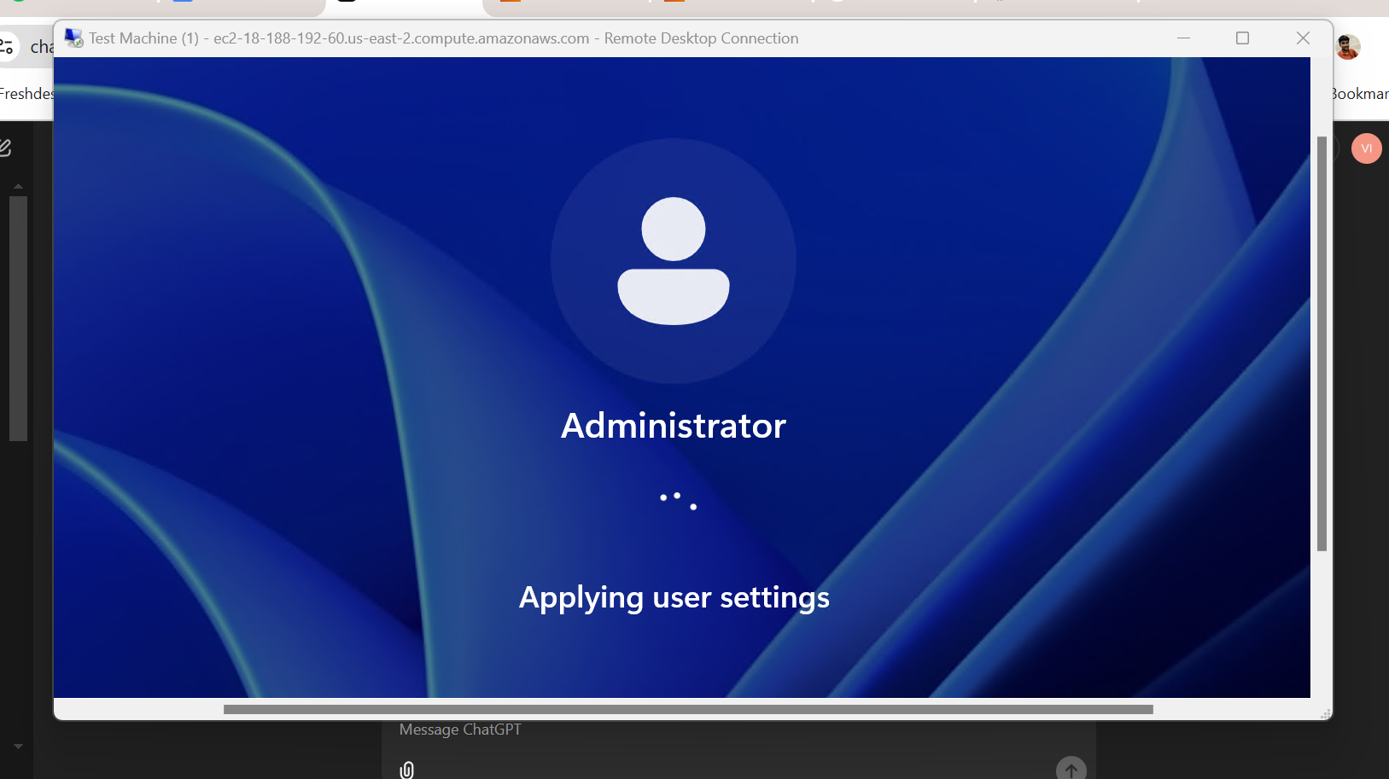

**Step 11: Windows machine is ready to use now**

**Step 12: Open “Command Prompt” to get the system info**

**Step 13: Share System Information**

* Paste the copied output into a text editor like Notepad.
* Save it as a .txt file for sharing.
* Transfer the file to your local machine using RDP file transfer or copy the data directly via clipboard sharing in the RDP session.

**//////////////////////////////////////////////////////////////////////////////////////////////////////////**